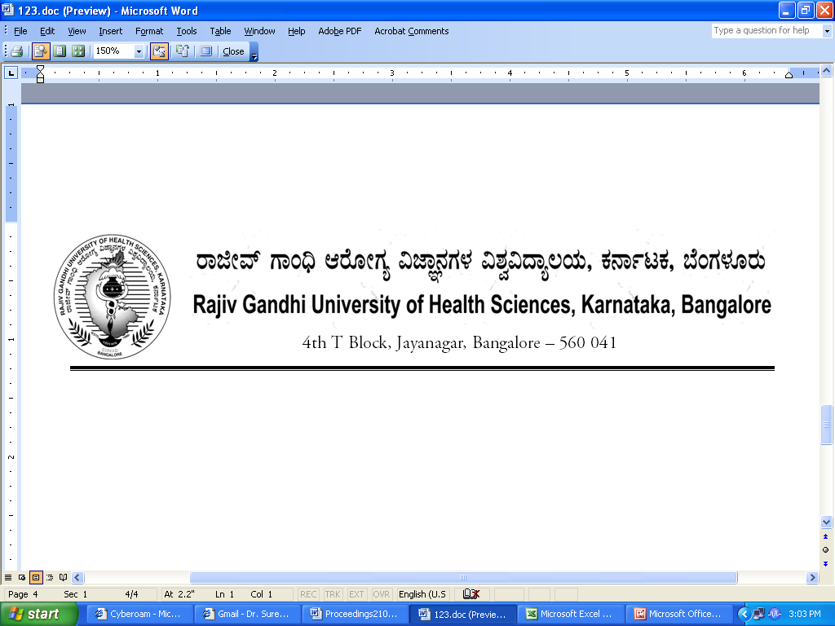
Reg (E)/UG/June –July/2018-19/67 Date: 18/09/2018

NOTIFICATION

Sub: | Conduct of 1st Phase MBBS Supplementary Theory examinations during September-2018
Ref: | Reg (E)/UG/June –July/2018-19/67, dated 25.07.2018

* * * * *

In continuation of this office Notification cited above, the following examination dates of 1st Phase MBBS September-2018 is rescheduled as shown below.
SL NO | Scheduled Dates | Day | Rescheduled Dates | Day
1 | 21.09.2018 | Friday | 22.09.2018 | Saturday

The principal of the respective colleges are hereby requested to display the rescheduled date prominently on their notice boards for information of the students

By Order

Sd/-
Dr. M.K.Ramesh
Registrar [Evaluation]
To:

All the Principals of the affiliated colleges for information.

Copy to:

- PA to Vice-Chancellor/Registrar/Registrar(E)/Finance Officer, RGUHS, Bangalore.
- All the Officers of the RGUHS, Bangalore.
- The Computer Section.
- Guard File.

